LAB NO# (08)
• LAB TITTLE:
“TO PRINT PYTHON PROGRAM USING WHILE LOOP TO SHOW A TABLE (MEAN TABLE OF A NUMBER)
• OBJECTIVE:
HOW TO PRINT PYTHON PROGRAM USING WHILE LOOP TO SHOW A TABLE (MEAN TABLE OF A NUMBER)
• TOOLS:
FOR PYTHON USING JUPYTER NOTEBOOK:
• PROCEDURE:
- First of all open the jupyter Notebook software in your Pc/Laptop.
- Then create a new project in pythan and save in some folder.
- Then start typing your program that you want to type.
- To print python program that using while loop to display the table a number

For example:
i=0
num=input("enter the number")
num=int (num)
while (i<=10):
print(f"{num} x {i}= {num*i} ")
i=i+1

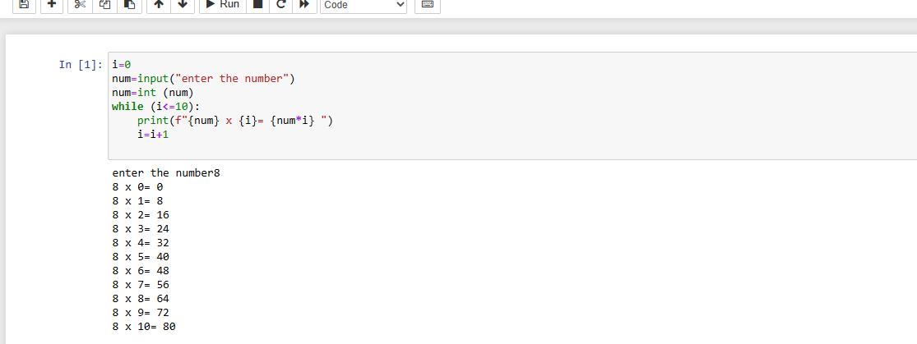

OBSERVATION
we are familiar with or observed that how to print python program using while loop to show a table (mean table of a number)

